

Website name

Profile

My Communities

Discover

Login

Logout

Feed

Song

Picture

Genre

Artist

Picture

Genre

Recommended Artist

Notifications

Post

Picture

Name poster

Song Name

Artist

Genre

Like

Post

Picture

Name poster

Song Name

Artist

Genre

Like

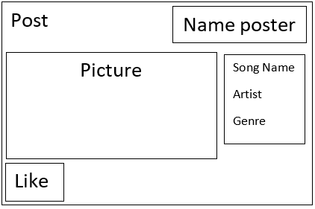



Website name

Profile

My Communities

Discover

Login

Logout

Genre

Picture

Genre

Picture

Genre

Picture

Genre

Picture

Genre

Picture

Genre

Picture



Website name

Profile

My Communities

Discover

Login

Logout

Profile

Picture

Banner

Friends

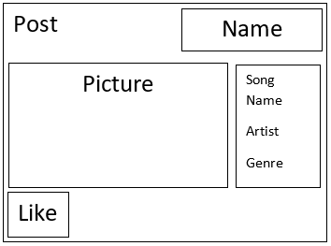

Favorite

genres / artists

Post

Picture

Name poster

Song Name

Artist

Genre

Like